**PRODIGY INFO-TECH   
 INTERNSHIP**

**Task 1**-Create a bar chart or histogram to visualize the distribution of categorical or continuous variable such as the distribution of ages or gender in population

**Tech Used**-IBM SPSS

**Data:**

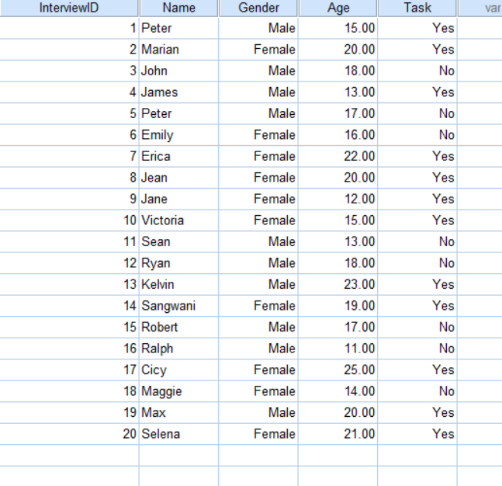

**Output:**

FREQUENCIES VARIABLES=Gender Task

/BARCHART FREQ

/ORDER=ANALYSIS.

**Frequencies**

|  |  |  |  |
| --- | --- | --- | --- |
| **Statistics** | | | |
|  | | Gender | Did you complete the task in past 7 days |
| N | Valid | 20 | 20 |
| Missing | 0 | 0 |

**Frequency Table**

|  |  |  |  |  |  |
| --- | --- | --- | --- | --- | --- |
| **Gender** | | | | | |
|  | | Frequency | Percent | Valid Percent | Cumulative Percent |
| Valid | Male | 10 | 50.0 | 50.0 | 50.0 |
| Female | 10 | 50.0 | 50.0 | 100.0 |
| Total | 20 | 100.0 | 100.0 |  |

|  |  |  |  |  |  |
| --- | --- | --- | --- | --- | --- |
| **Did you complete the task in past 7 days** | | | | | |
|  | | Frequency | Percent | Valid Percent | Cumulative Percent |
| Valid | No | 8 | 40.0 | 40.0 | 40.0 |
| Yes | 12 | 60.0 | 60.0 | 100.0 |
| Total | 20 | 100.0 | 100.0 |  |

**Bar Chart**

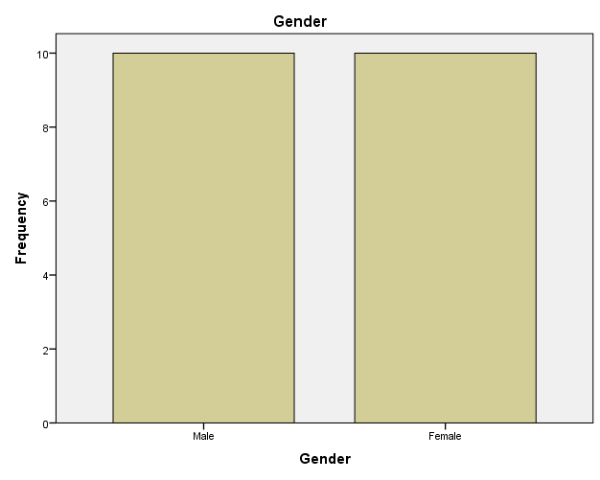

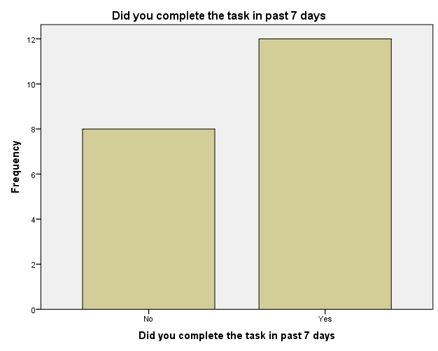

FREQUENCIES VARIABLES=Age

/FORMAT=NOTABLE

/STATISTICS=STDDEV RANGE MINIMUM MAXIMUM

/HISTOGRAM NORMAL

/ORDER=ANALYSIS.

**Frequencies**

|  |  |  |
| --- | --- | --- |
| **Statistics** | | |
| Age | | |
| N | Valid | 20 |
| Missing | 0 |
| Std. Deviation | | 3.84537 |
| Range | | 14.00 |
| Minimum | | 11.00 |
| Maximum | | 25.00 |

